**Dashboard UI Design Planning**

**Stage 1:**

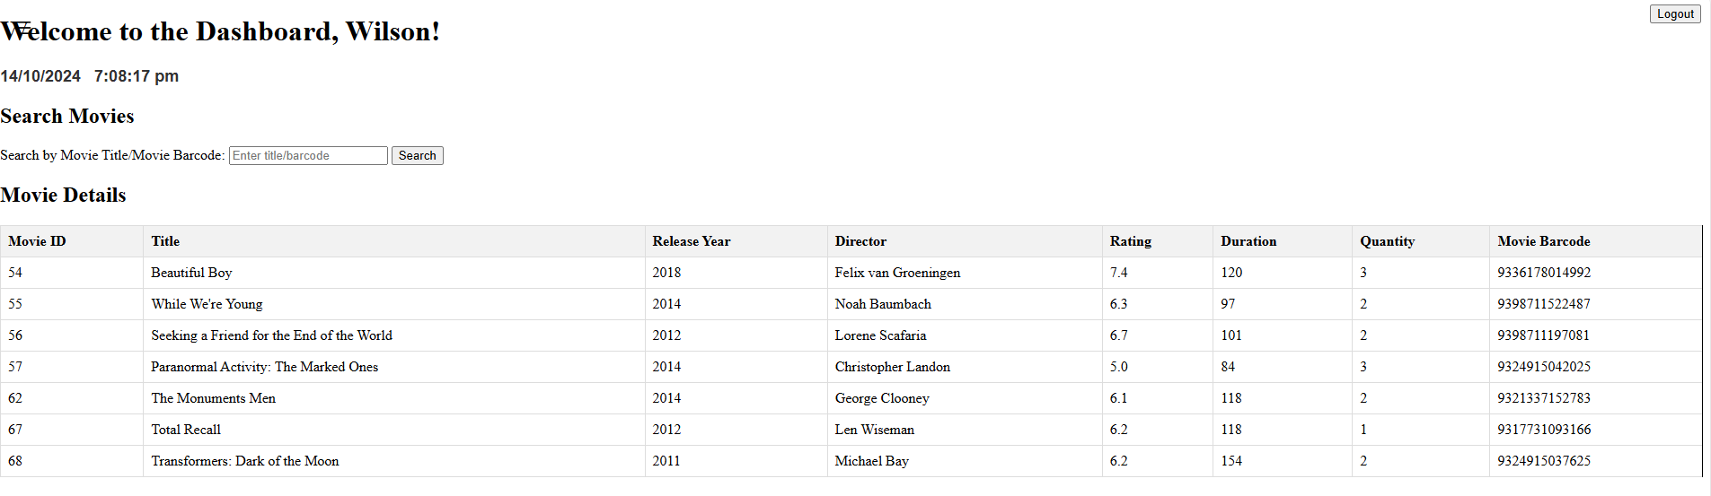

**Stage 2 Ideas:**

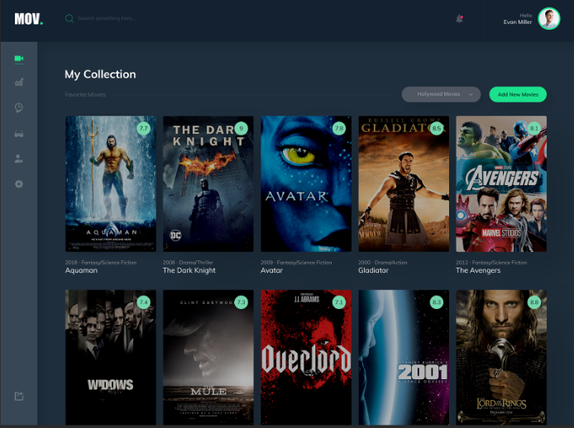

Things to fix from the current design:

**Header**

* Logo Button on the left hand corner (DONE)
* A search bar right next to it when I press the search bar and start keying in the letters, it will automatically start filtering out the movies that have common letter or words that I have keyed in under the search options.
* On the Right corner it’s an icon saying Hi (User, based on the staff who logged in) and when I press the icon a drop down menu with 2 options would come out (Profile and Logout) (DONE)

**Left side-bar**

* 5 Icons vertically aligned (each representing a functionality) upon hovering the icon will be highlighted in the background and the name of the icon will pop out

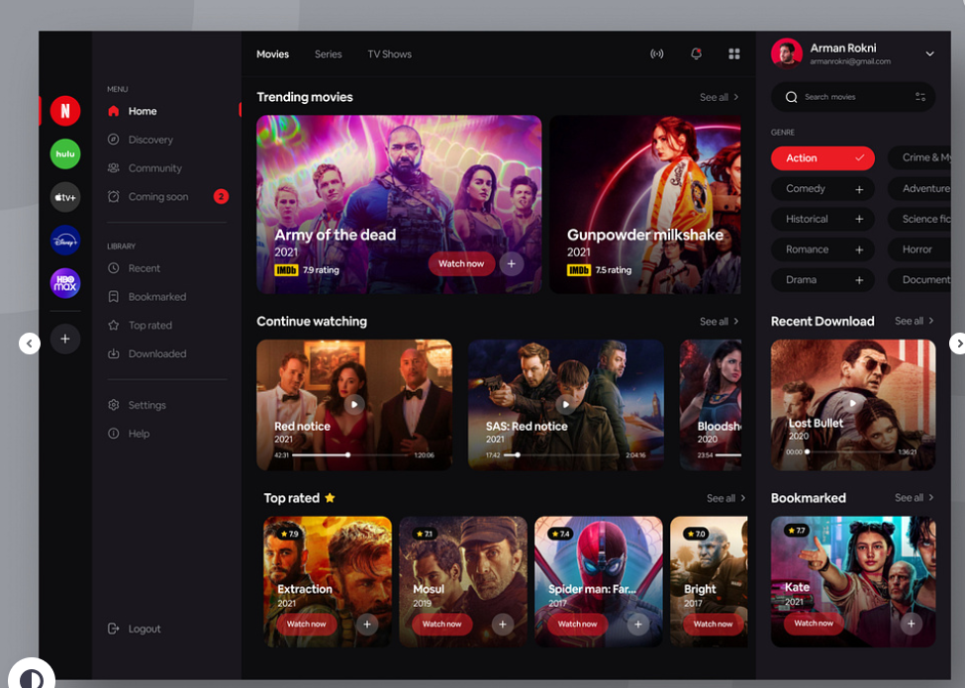

**2 sidebar menus:**

**Left side** (all the Features: Rent DVD, Return DVD and etc)

* Add New Movie
* Add New Customer
* Add New Staff
* Renting DVDs
* Returning DVDs
* Delete Movie

**Right side** (Search Bar and Genre Selection where once I press that specific genre button, it will then help me filter the movie based on the genre)

* Little avatar and my email will be shown (have a little drop down menu where I can choose to log out

**Sample Picture from IMDB**

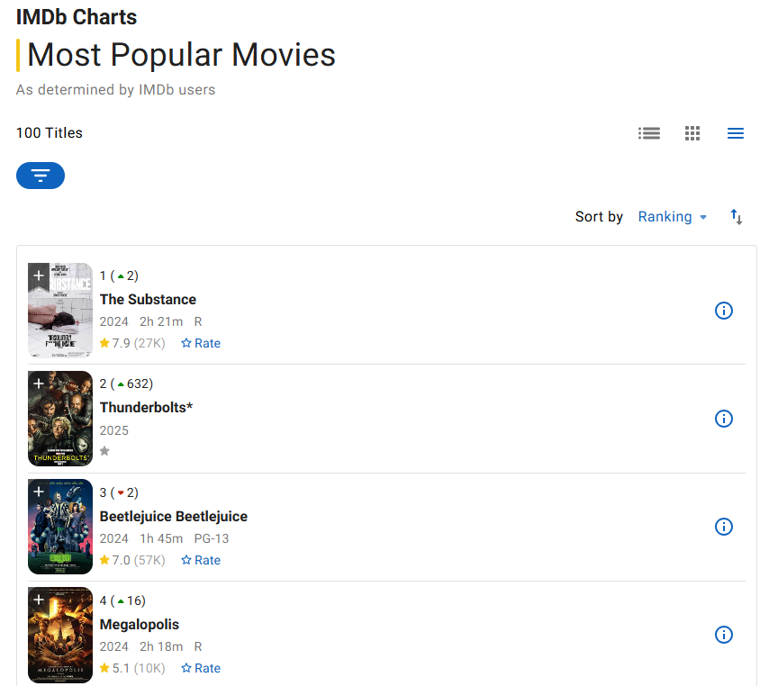

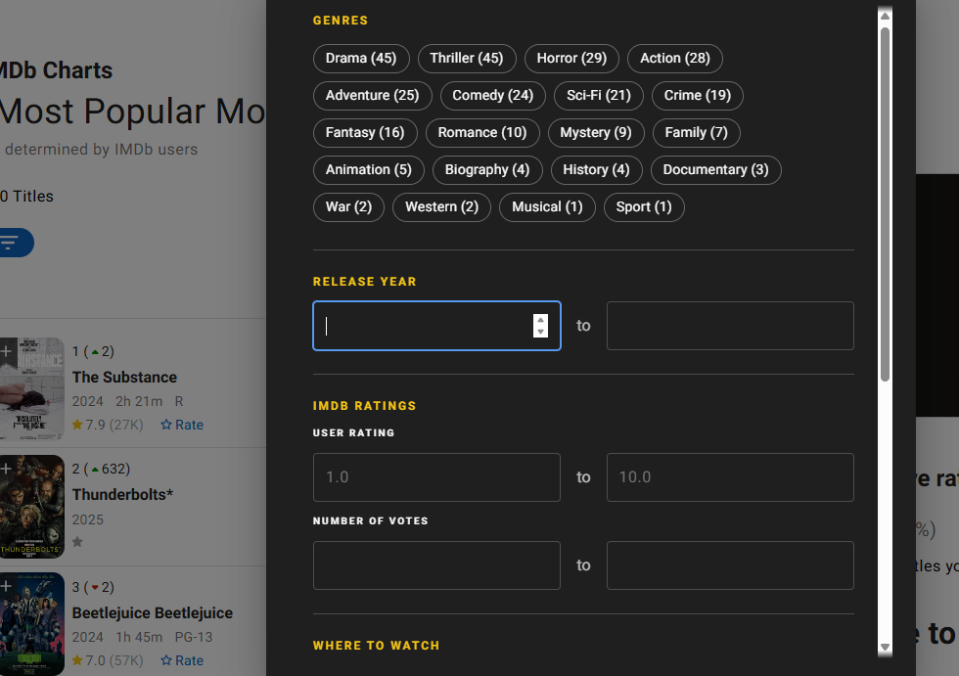

The wifi looking button allows me to filter the movie based on Genre (when pressing the genre I want, it will then automatically show the movies that has the genre being pressed. (pressing the same genre will remove the genre selection).

There is a number beside each genre button (it represents the number of movies that is related to that genre)

For the movie images, I can use grab images from OMDB API.

Genre Table